CONSER Standard Record #2
Monday, 4/16/2007

Slide | Comment
Slide 11  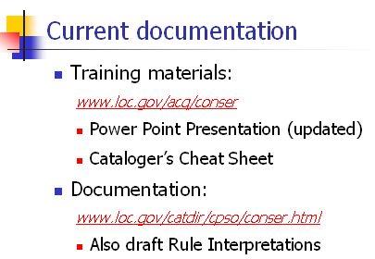 | Beth T.: basic serials: came to things that will change but need to know them. The cheat sheet went over so well that people also wanted a sheet for the current standard.
Slide 25  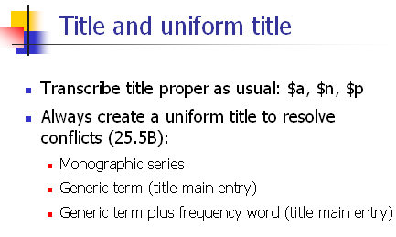 | Beth T: Do the conser standard record guidelines apply to newspapers? Will catalogers create uniform titles to resolve conflicts for newspaper titles as in the past, or not?
Slide 50:  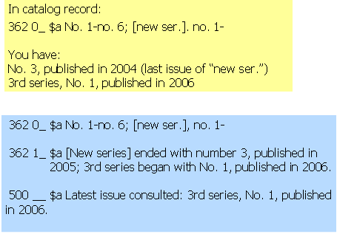 | How to convert complex 362 0 to 362 1? [note on slide]
Slide 64:  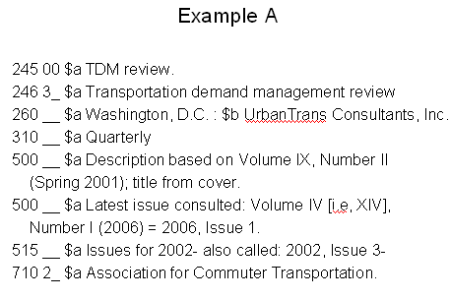 | Beth T.: I agonize over the 515: how to phrase it  Gretchen : Something diff for me is the option of using transcription for roman numerals, having just presented the beginning course & told people not to do that
Slide 65:  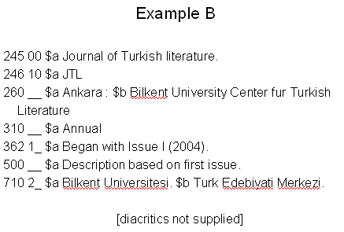 | Linda G: JTL: I would especially emphasize that sometimes transcribing what you see on the chief source is not the same, since sometimes you don’t transcribe the title at all, for example, “JTL” is only in the 246 in this case, not in the 245 $b  I-chene: Does this [the MAP] only apply only to serials or to all continuing resources?
Slide 66:  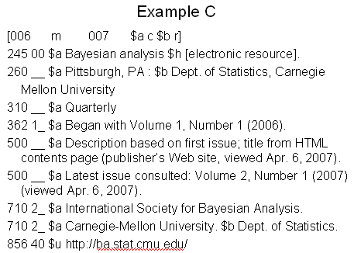 | Anonymous comments written on slide:  --No 538 [Mode of access WWW] hurray!  --I second that
Discussion question #1 | Beth: I will need to look more closely the proposed LC RIs  Laura : Yes, the RIs. And with us, we only have one serials cataloging person—who is retiring in a week and a half. So we will be training our monograph catalogers to do serials cataloging.  Also, as a representative in provincial consortium I am the only one who knows about the CONSER Standard Record. None of the others have been keeping up with this. I will need to take this back to the consortium to incorporate this [changes from the MAP] in the regional policies
Discussion question #2   | Linda: The people who sell out for the basic serials workshop are mainly cataloging paraprofessionals & acquisitions staff, and many have never bought into some of the esoteric aspects of traditional practice. I think most staff are going to be really happy with it [the MAP], for what it’s worth  Anonymous [written on slide]: I think everyone in the library needs to know about this. Encouraging staff to read records so that they can encourage users to read web opac records  Gretchen: I would just comment that I think the records [according to the CONSER standard record guidelines] are so much better that we won’t have to tell them about it, they’ll be able to read the records themselves [much more easily] and tell what is going on.
Discussion question #3   | Laura: Organizational change at our institution has made me think more about change and how people think about change. Sometimes we get so comfortable doing things one way, that we forget who we are cataloging for. I have been working on the reference desk & that has made me think more about what kinds of access points I’m adding to my records. Am I helping someone, or am I just adhering to some rule? If you are creating a record right, it will provide a service. That’s one of the things I keep going back to, that cataloging is a user service, just as much as reference.

